VELAMMAL COLLEGE OF ENGINEERING AND TECHNOLOGY



DEPARTMENT OF
COMPUTER SCIENCE AND ENGINEERING

NAME : S.SWETHA
UNIVERSITY REGISTER NO : 913121104111
SEMESTER : I st SEMESTER
BRANCH : COMPUTER SCIENCE AND
ENGINEERING

BONAFIDE CERTIFICATE

This is to certify that this project report “Hotel Management is the bonafide work of Miss. S.SWETHA Reg. No. 913121104111 of I semester B.E. COMPUTER SCIENCE AND ENGINEERING degree who carried out the project work under my supervision.

STAFF IN CHARGE  SIGNATURE  Computer Science and Engineering,  Velammal College of Engineering and Technology  Madurai-625 009. | HEAD OF THE DEPARTMENT SIGNATURE  Computer Science and Engineering, Velammal College of Engineering and Technology  Madurai-625 009.

ABSTRACT
Python is a widely used high-level programming language for general-purpose programming, created by Guido Van Rossum and first released in 1991. An interpreted language, Python has a design philosophy that emphasizes code readability (notably using whitespace indentation to delimit code blocks rather than curly brackets or keywords), and a syntax that allows programmers to express concepts in fewer lines of code that might be used in languages such as C++ or Java.
Data processing is the collection and manipulation of items of data to produce meaningful information. It is also termed as the conversion of raw data to machine-readable form and its subsequent processing (such as storing, updating, rearranging, printing) by a computer.
The main objective of our project is to create page for ordering dishes in a restaurant. Here what we do is that, we create a static webpage for a restaurant to order food items. The page displays the menu with all the dishes available in the restaurant. The customer can select the quantity of each dish that he wants to order. After the selection process, click on the TOTAL button. It displays the total cost of the meal with the service charge and GST. Click on the RESET button to change the quantity of all the dishes and to order again freshly. At last click on the EXIT button to close.

INDEX

CHAPTER | TITLE | PAGE NO
1 | INTRODUCTION  - OVERVIEW  - PACKAGES  - IMPORTANCE  - ADVANTAGES  - SUMMARY | 5  5  6  6  6
2 | SYSTEM SPECIFICATION  - HARDWARE SPECIFICATION  - SOFTWARE SPECIFICATION | 7  7
3 | ALGORITHM AND FLOWCHART | 8-9
4 | CONCLUSION | 10
5 | APPENDIX  - SOURCE CODE  - SCREENSHOTS | 11-17  18

CHAPTER 1
INTRODUCTION
1.1 OVERVIEW:
Online food ordering is a process of ordering food from a local restaurant or food cooperative through a web page or app. A customer will select a favorite restaurant and choose the dishes available in the restaurant which he wants to buy. After selecting the dishes, the customer has to pay money using debit card or credit card or by cash on delivery mode. Here we have done a program to order dishes and calculating the total cost including all the service taxes and GST. All these are displayed in a static page.

1.2 PACKAGES:
Tkinter is a Python’s defacto standard GUI(Graphical User Interface) package. Python 3.7 incorporate the “themed Tk” functionality of Tk 8.5. This allows Tk widgets to be easily themed to look like native desktop environment in which the application is running, thereby addressing a long standing criticism of Tk(and hence of Tkinter). We have also used packages like time and date to display the time and date.
1.3 IMPORTANCE:
One of the fastest growing business tools in the restaurant industry is the ability of the customer to enter an order online. Online ordering has changed the way that restaurants with large volume takeout business can operate. No longer it is necessary to have multiple people tied up on the phones taking order and communication errors have been minimized.

1.4 ADVANTAGES:
Today ,many people prefer to order food online. Statistics show that about 69% of the customers order food online using a mobile. One of the biggest issues with phone conversations is that misunderstandings can happen quite easily. Usually due to the noise, either in the restaurant or on the other end of the line, all it takes is one mistake to compromise an order and frustrate a customer. With online ordering, all preferences are specified directly by the customer, so there is no room for confusions or misunderstandings. Online ordering system provides the customer with up to the minute updated menu.
1.5 SUMMARY:
Thus, we saw about online food ordering system, its importance and its advantages. Our project is based on this concept. We have created a static page to display the dishes available in the restaurant. The customer shall select his/her desired dish and generate the total cost to be paid by them.
CHAPTER 2
SYSTEM SPECIFICATION
  - HARDWARE SPECIFICATIONS

- Processor : Intel dual core
- Processor speed : 1.04GHZ
- Ram : 1GB
- Hard disc : 20GB hard disc
- Monitor : LCD
- Keyboard : MM Keyboard(Usb)
- Mouse : Optical mouse(Usb)

  - SOFWARE SPECIFICATIONS

- OS : Window XP or above
- Language (IDLE) : Python 3.7
- Packages : NumPy >= 1.6.1 , matplotlib >= 1.0.0
- IDE (set up) : Anaconda (Whatever IDE you have used in the
Project)

CHAPTER 3
ALGORITHM AND FLOWCHART
ALGORITHM

STEP 1 : Start the program
STEP 2 : Import the module tkinter, time and datetime
STEP 3 : Call root=Tk() function
STEP 4 : Set the title as RESTAURANT MANAGEMENT SYSTEM
STEP 5 : Display the name of the restaurant, time and date
STEP 6 : Define a function for getting input from the user, initializing the
cost of each dish and computing total cost including all the taxes
STEP 7 : Define a function for resetting values and for entering new
values
STEP 8 : Define a function for exiting
STEP 9 : Initialize rows and columns and set spacing between them. Also
select the font of the output
STEP 10 : Exit the program using root.mainloop()
STEP 11 : End the program

FLOWCHART
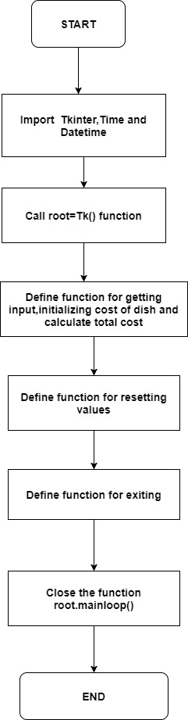
CHAPTER 4
CONCLUSION

Thus, we have designed a program for generating the total cost of food items ordered which is based on the concept of online food ordering system. We have the source code and the output for the program developed by our group in the following page for your verification. (For future further developments we are still ongoing more case studies regarding this project)

APPENDIX - I
SOURCE CODE
from tkinter import*
import time
import datetime
root=Tk()
root.geometry("1600x8000")
root.title("Restaurant Management System")
Tops=Frame(root, width=1600,relief=SUNKEN)
Tops.pack(side=TOP)
f1=Frame(root,width=800,height=700,relief=SUNKEN)
f1.pack(side=LEFT)
localtime=time.asctime(time.localtime(time.time()))
lblInfo=Label(Tops,font=('arial',50,'bold'),text="VELAMMAL RESTAURANT",fg="Blue Violet",bd=10,anchor='w')
lblInfo.grid(row=0,column=0)
lblInfo=Label(Tops,font=('arial',20,'bold'),text=localtime,fg="Blue Violet",bd=10,anchor='w')
lblInfo.grid(row=1,column=0)
def Ref():
if (Idly.get()==""):
CoIdly=0
else:
CoIdly=float(Idly.get())
if (Dosa.get()==""):
CoDosa=0
else:
CoDosa=float(Dosa.get())
if (Ven_Pongal.get()==""):
CoVen_Pongal=0
else:
CoVen_Pongal=float(Ven_Pongal.get())
if (Poori.get()==""):
CoPoori=0
else:
CoPoori=float(Poori.get())
if (Methu_Vada.get()==""):
CoMethu_Vada=0
else:
CoMethu_Vada=float(Methu_Vada.get())
if (Pepsi.get()==""):
CoPepsi=0
else:
CoPepsi=float(Pepsi.get())
if (Cocacola.get()==""):
CoCocacola=0
else:
CoCocacola=float(Cocacola.get())
CostofIdly =CoIdly * 20
CostofPepsi=CoPepsi * 25
CostofCocacola=CoCocacola * 25
CostofDosa = CoDosa* 40
CostofVen_Pongal = CoVen_Pongal * 35
CostPoori = CoPoori* 35
CostMethu_Vada=CoMethu_Vada* 10
CostofMeal= "Rs", str('%.2f' %(CostofIdly+CostofPepsi+CostofCocacola+CostofDosa+CostofVen_Pongal+CostPoori+CostMethu_Vada))
PayTax=((CostofIdly+CostofPepsi+CostofCocacola+CostofDosa+CostofVen_Pongal+CostPoori+CostMethu_Vada) * 0.2) TotalCost=(CostofIdly+CostofPepsi+CostofCocacola+CostofDosa+CostofVen_Pongal+CostPoori+CostMethu_Vada)
Ser_Charge= ((CostofIdly+CostofPepsi+CostofCocacola+CostofDosa+CostofVen_Pongal+CostPoori+CostMethu_Vada)/99)
Service = "Rs", str ('%.2f' % Ser_Charge)
OverAllCost ="Rs", str ('%.2f' % (PayTax+TotalCost+Ser_Charge))
PaidTax= "Rs", str ('%.2f' % PayTax)
Service_Charge.set(Service)
Cost.set(CostofMeal)
Tax.set(PaidTax)
SubTotal.set(CostofMeal)
Total.set(OverAllCost)
def qExit():
root.destroy()
def Reset():
rand.set("")
Idly.set("")
Dosa.set("")
Ven_Pongal.set("")
SubTotal.set("")
Total.set("")
Service_Charge.set("")
Pepsi.set("")
Cocacola.set("")
Tax.set("")
Cost.set("")
Poori.set("")
Methu_Vada.set("")
rand = StringVar()
Idly=StringVar()
Dosa=StringVar()
Ven_Pongal=StringVar()
SubTotal=StringVar()
Total=StringVar()
Service_Charge=StringVar()
Pepsi=StringVar()
Cocacola=StringVar()
Tax=StringVar()
Cost=StringVar()
Poori=StringVar()
Methu_Vada=StringVar()
lblIdly= Label(f1, font=('arial', 16, 'bold'),text="Idly",bd=16,anchor="w")
lblIdly.grid(row=0, column=0)
txtIdly=Entry(f1, font=('arial',16,'bold'),textvariable=Idly,bd=10,insertwidth=4,bg="powder blue",justify='right')
txtIdly.grid(row=0,column=1)
lblDosa= Label(f1, font=('arial', 16, 'bold'),text="Dosa",bd=16,anchor="w")
lblDosa.grid(row=1, column=0)
txtDosa=Entry(f1, font=('arial',16,'bold'),textvariable=Dosa,bd=10,insertwidth=4,bg="powder blue",justify='right')
txtDosa.grid(row=1,column=1)
lblVen_Pongal= Label(f1, font=('arial', 16, 'bold'),text="Ven_Pongal ",bd=16,anchor="w")
lblVen_Pongal.grid(row=2, column=0)
txtVen_Pongal=Entry(f1, font=('arial',16,'bold'),textvariable=Ven_Pongal,bd=10,insertwidth=4,bg="powder blue",justify='right')
txtVen_Pongal.grid(row=2,column=1)
lblPoori= Label(f1, font=('arial', 16, 'bold'),text="Poori",bd=16,anchor="w")
lblPoori.grid(row=3, column=0)
txtPoori=Entry(f1, font=('arial',16,'bold'),textvariable=Poori,bd=10,insertwidth=4,bg="powder blue",justify='right')
txtPoori.grid(row=3,column=1)

lblMethu_Vada= Label(f1, font=('arial', 16, 'bold'),text="Methu_Vada",bd=16,anchor="w")
lblMethu_Vada.grid(row=4, column=0)
txtMethu_Vada=Entry(f1, font=('arial',16,'bold'),textvariable=Methu_Vada,bd=10,insertwidth=4,bg="powder blue",justify='right')
txtMethu_Vada.grid(row=4,column=1)

lblPepsi= Label(f1, font=('arial', 16, 'bold'),text="Pepsi",bd=16,anchor="w")
lblPepsi.grid(row=0, column=2)
txtPepsi=Entry(f1, font=('arial',16,'bold'),textvariable=Pepsi,bd=10,insertwidth=4,bg="powder blue",justify='right')
txtPepsi.grid(row=0,column=3)
lblCocacola= Label(f1, font=('arial', 16, 'bold'),text="Cocacola",bd=16,anchor="w")
lblCocacola.grid(row=1, column=2)
txtCocacola=Entry(f1, font=('arial',16,'bold'),textvariable=Cocacola,bd=10,insertwidth=4,bg="powder blue",justify='right')
txtCocacola.grid(row=1,column=3)
lblCost= Label(f1, font=('arial', 16, 'bold'),text="Cost of Meal",bd=16,anchor="w")
lblCost.grid(row=2, column=2)
txtCost=Entry(f1, font=('arial',16,'bold'),textvariable=Cost,bd=10,insertwidth=4,bg="powder blue",justify='right')
txtCost.grid(row=2,column=3)
lblService= Label(f1, font=('arial', 16, 'bold'),text="Service Charge",bd=16,anchor="w")
lblService.grid(row=3, column=2)
txtService=Entry(f1, font=('arial',16,'bold'),textvariable=Service_Charge,bd=10,insertwidth=4,bg="powder blue",justify='right')
txtService.grid(row=3,column=3)
lblStateTax= Label(f1, font=('arial', 16, 'bold'),text="GST",bd=16,anchor="w")
lblStateTax.grid(row=4, column=2)
txtStateTax=Entry(f1, font=('arial',16,'bold'),textvariable=Tax,bd=10,insertwidth=4,bg="powder blue",justify='right')
txtStateTax.grid(row=4,column=3)

lblTotalCost= Label(f1, font=('arial', 16, 'bold'),text="Total Cost",bd=16,anchor="w")
lblTotalCost.grid(row=5, column=2)
txtTotalCost=Entry(f1, font=('arial',16,'bold'),textvariable=Total,bd=10,insertwidth=4,bg="powder blue",justify='right')
txtTotalCost.grid(row=5,column=3)
btnTotal=Button(f1,padx=16,pady=8,bd=16,fg="black",font=('arial',16,'bold'),width=10,text="Total",bg="powder blue",command=Ref).grid(row=7,column=1)
btnReset=Button(f1,padx=16,pady=8,bd=16,fg="black",font=('arial',16,'bold'),width=10,text="Reset",bg="powder blue",command=Reset).grid(row=7,column=2)
btnExit=Button(f1,padx=16,pady=8,bd=16,fg="black",font=('arial',16,'bold'),width=10,text="Exit",bg="powder blue",command=qExit).grid(row=7,column=3)
root.mainloop()

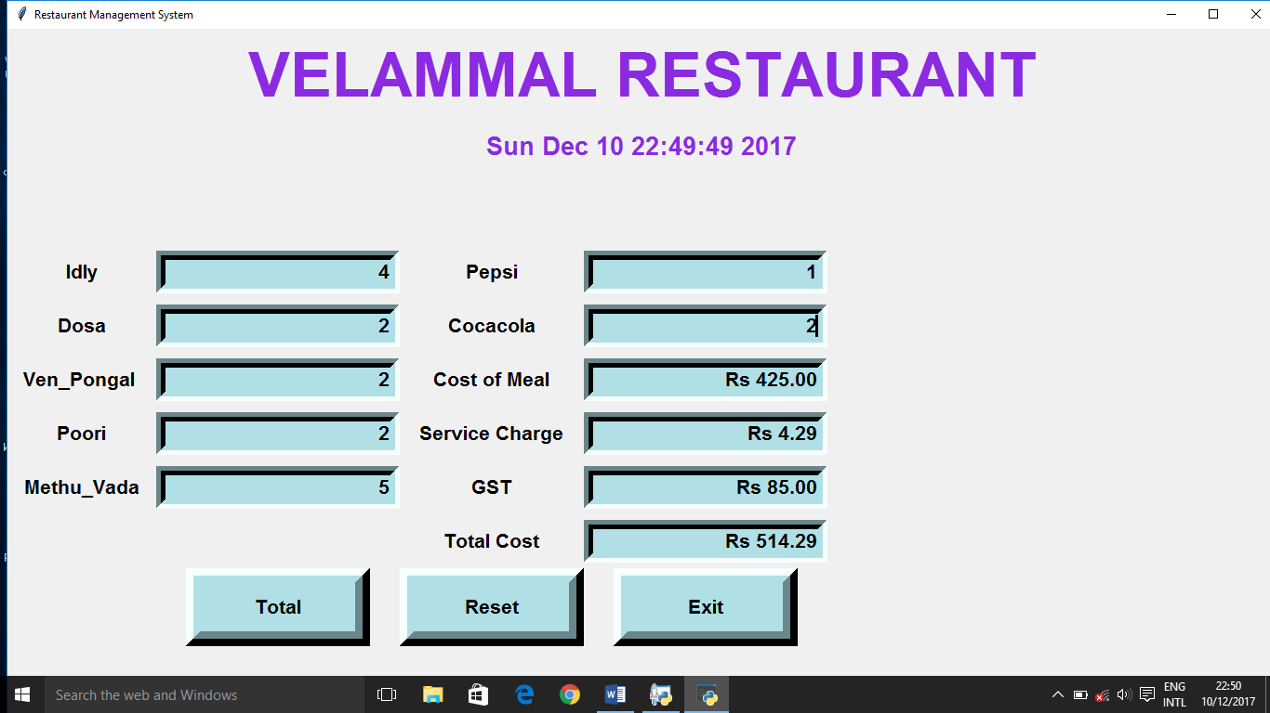
APPENDIX – II
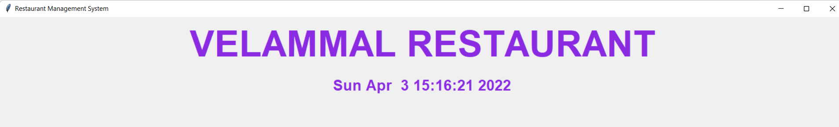
OUTPUT

